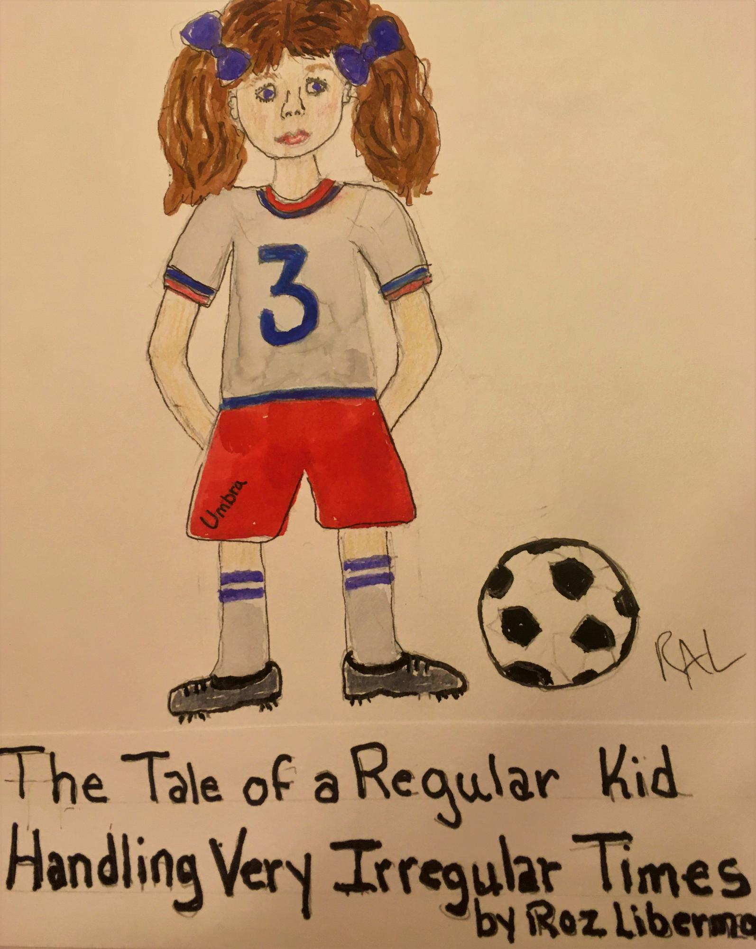

**TITLE PAGE**

**The Tale of a Regular Kid Facing Very Irregular Times**

by Roz Liberman

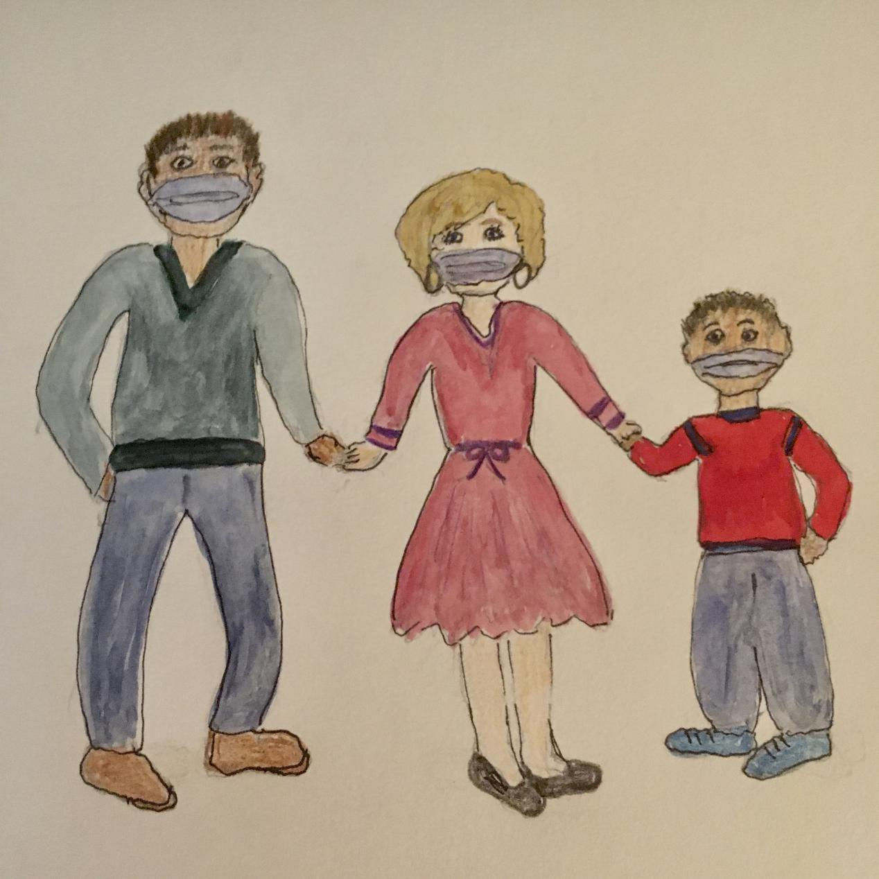

Everyone was wearing masks but not the kind we wear for Halloween. It

didn’t really make much sense to me since these masks were all boring blue

half masks, and no one was even wearing a costume! What fun is that?

Everything was changing rapidly, and to be honest, it was all a total

mystery to me. Let me start at the beginning, and maybe we can figure it

out together.

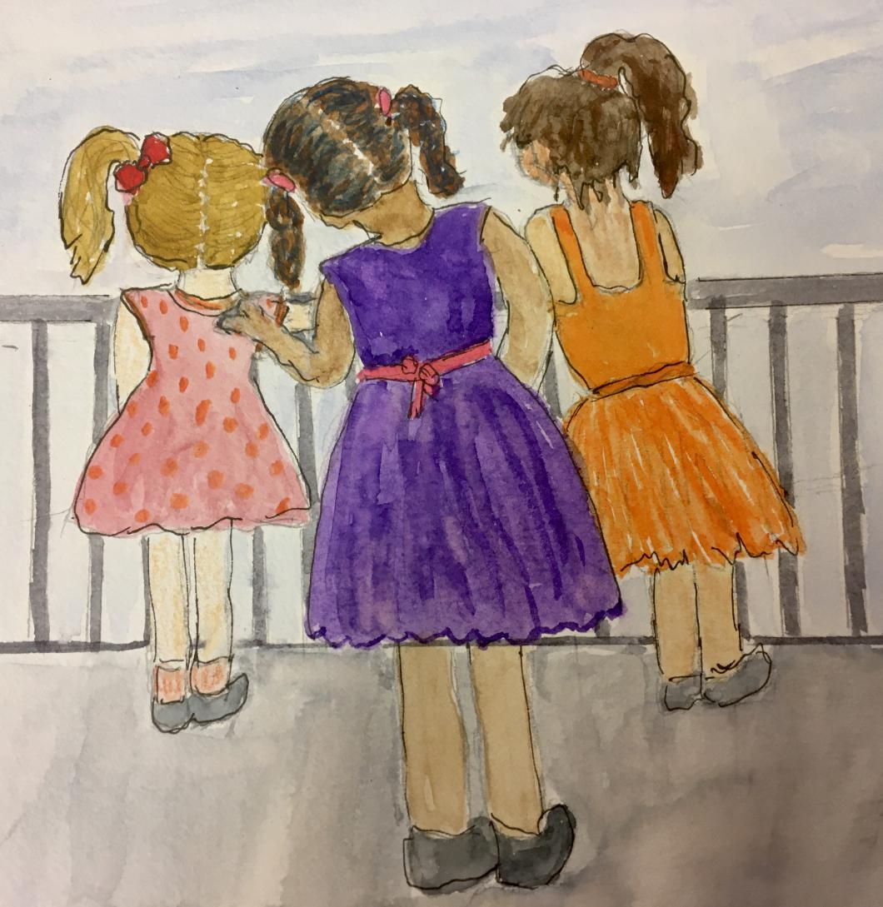

Things had been totally normal at home, at school, and everywhere else

until sometime between Valentines Day and Spring Break. I loved my

fourth grade teacher, really loved my new soccer team, the Power Girls,

was still best friends with Stacy and Emma, and my big sister, Kacey, was

even being somewhat civil to me. She was usually a real pain, but lately,

even she was nicer and friendlier. Maybe,the fact everything was perfect

was a clue; maybe great times can’t last forever, so I should have been

prepared for the BIG CHANGE! Do you ever think that way? Do you believe

life can be terrific all the time, or do you think good times always have to

end, and bad times are sure to follow? I guess those are what my mom

often calls “Life’s Big Questions”.

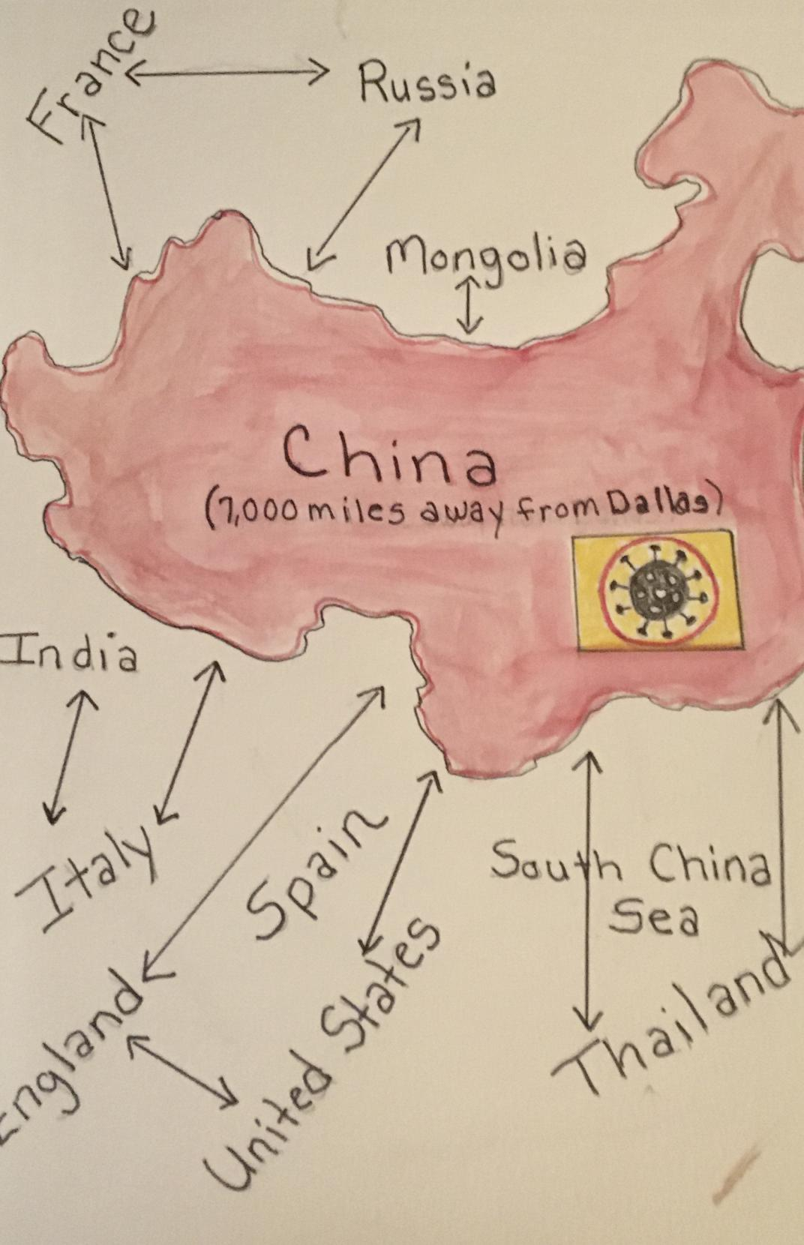

Anyway, little by little, things started to change. It kind of began when

I overheard my parents talking about a big disease spreading all over China.

It sounded like a kind of flu but way worse. It didn’t really seem like a big

deal to me since China was so far away, and I didn’t even know anyone who

lived there. Well, that’s not totally true since I did know some of my

friends had relatives who lived there, but they hardly ever saw them, so it

didn’t seem very important to me.

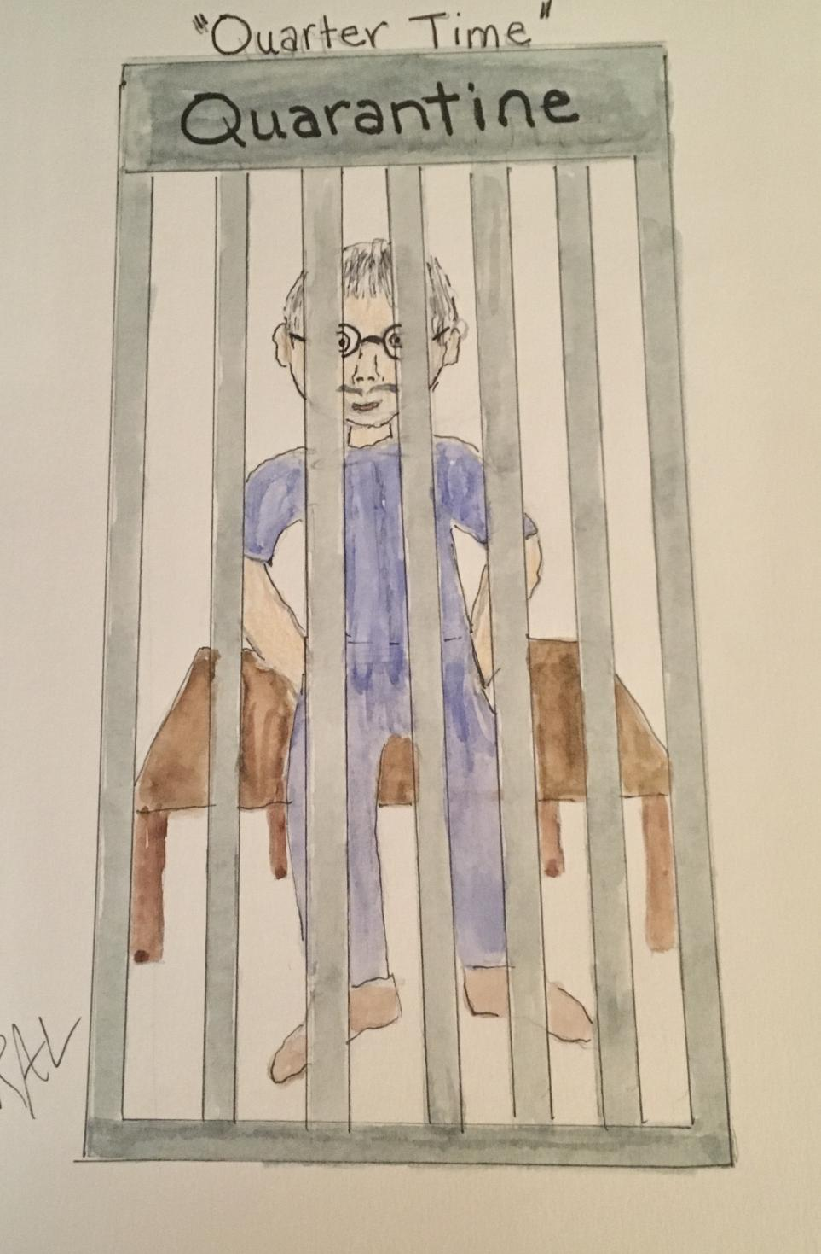

Nothing much happened for awhile, but then, one of my classmates, Kim

Zhou, came to school all upset because her dad had been visiting her

grandparents in China and was not allowed back home because of the same

“flu” my parents had been discussing in China. He had to stay in something

called *quartertime* for two whole weeks to make sure he would not spread

the disease to others. Once about a year earlier, one of my neighbor’s dog

had to be *quartertimed* because he bit, Zachary, a little boy down the

street, for no reason. I wondered if this flu also made people bite each

other; that would be really weird and scary. I sure hoped Kim’s dad didn’t

bite anyone.

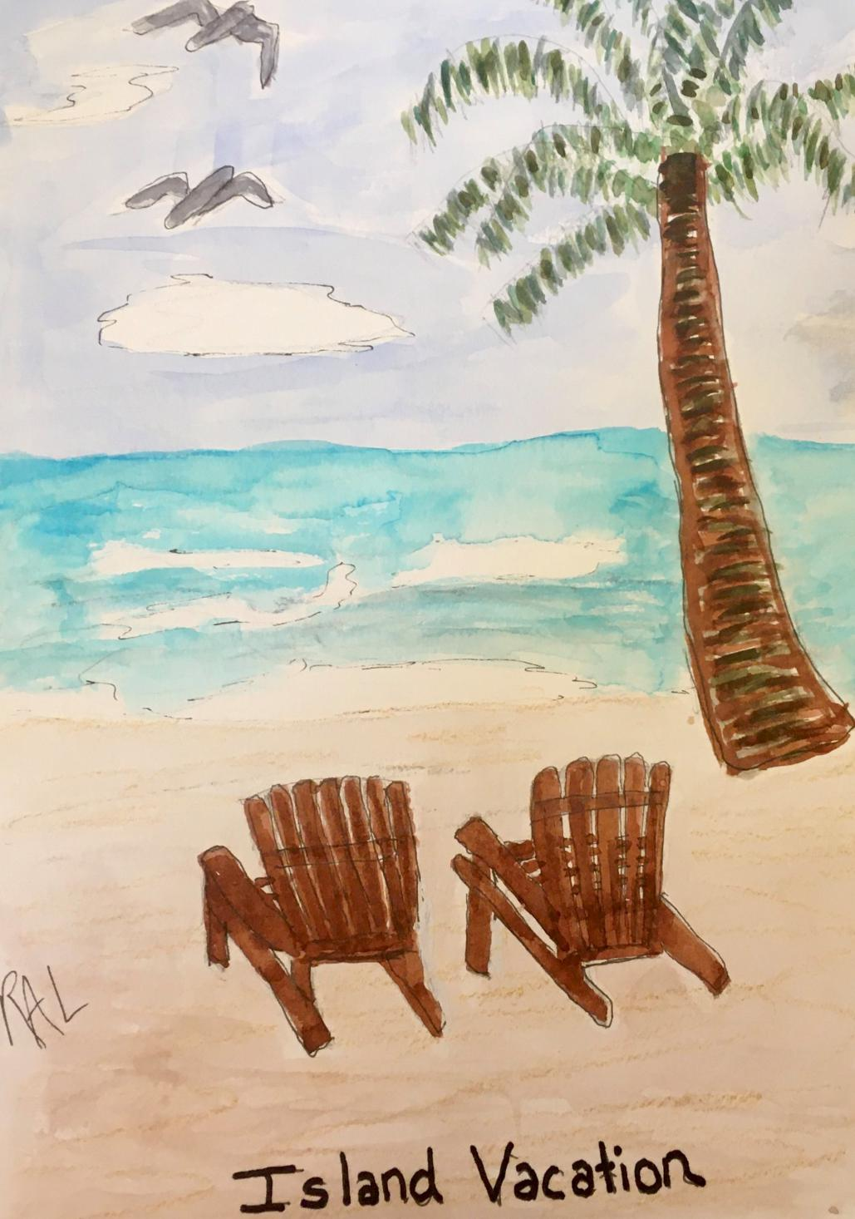

After that, my parents announced we had to cancel our plans for

Spring Break since they did not think it was a safe time to be traveling. My

mom announced very calmly, “ Kids, I am so sorry to tell you, but your dad

and I feel it isn’t safe for us to go anywhere for Spring Break. We wouldn’t

want to risk any of us becoming sick. I am sure you understand; it is always

better to be safe than sorry.”

Understand? Was she insane? I looked at her like she had gone crazy

and replied, “What do you mean? That makes no sense at all. It’s not like we

we’re going to a wild jungle; we’re merely taking a cruise with Stacy and

Emma’s families not far from Florida. What could possibly be dangerous

about that? You must be kidding! ”

I couldn’t believe Kacey wasn’t just as angry as I was. Why was she

choosing this time to suddenly be quiet and cooperative? Mom gave me one

of her half smiles I hated so much as she added,” I understand your

disappointment, but our decision is final. I promise you will have a good time going to a great soccer camp here with your friends instead.”

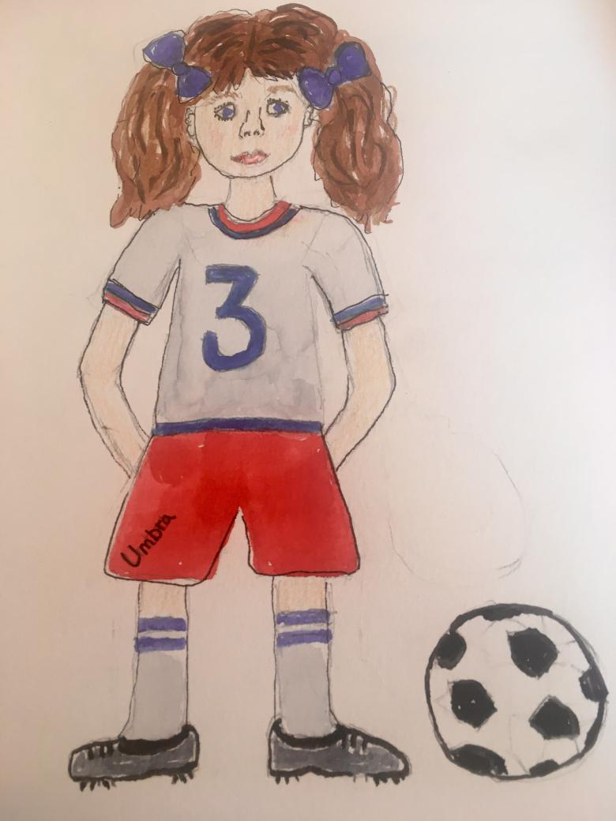

I ran out of the room to call Stacy and Emma and tell them about this

disaster! They were both shocked and really upset, but we were sure their

parents would talk mine out of canceling. As I waited in my room to hear

back from them, I kept praying my parents would realize their mistake and

decide we could go after all. When my mom told me Stacy and Emma were

at the front door, I was so excited. I was sure they had good news, but one

look at their faces told me I was wrong. They said their parents totally

agreed with my parents, and they were going to cancel their plans too.

Now, we all had to stay home in boring Dallas and attend all day soccer

camp since our folks would be working instead of going on vacation . What a total bummer!

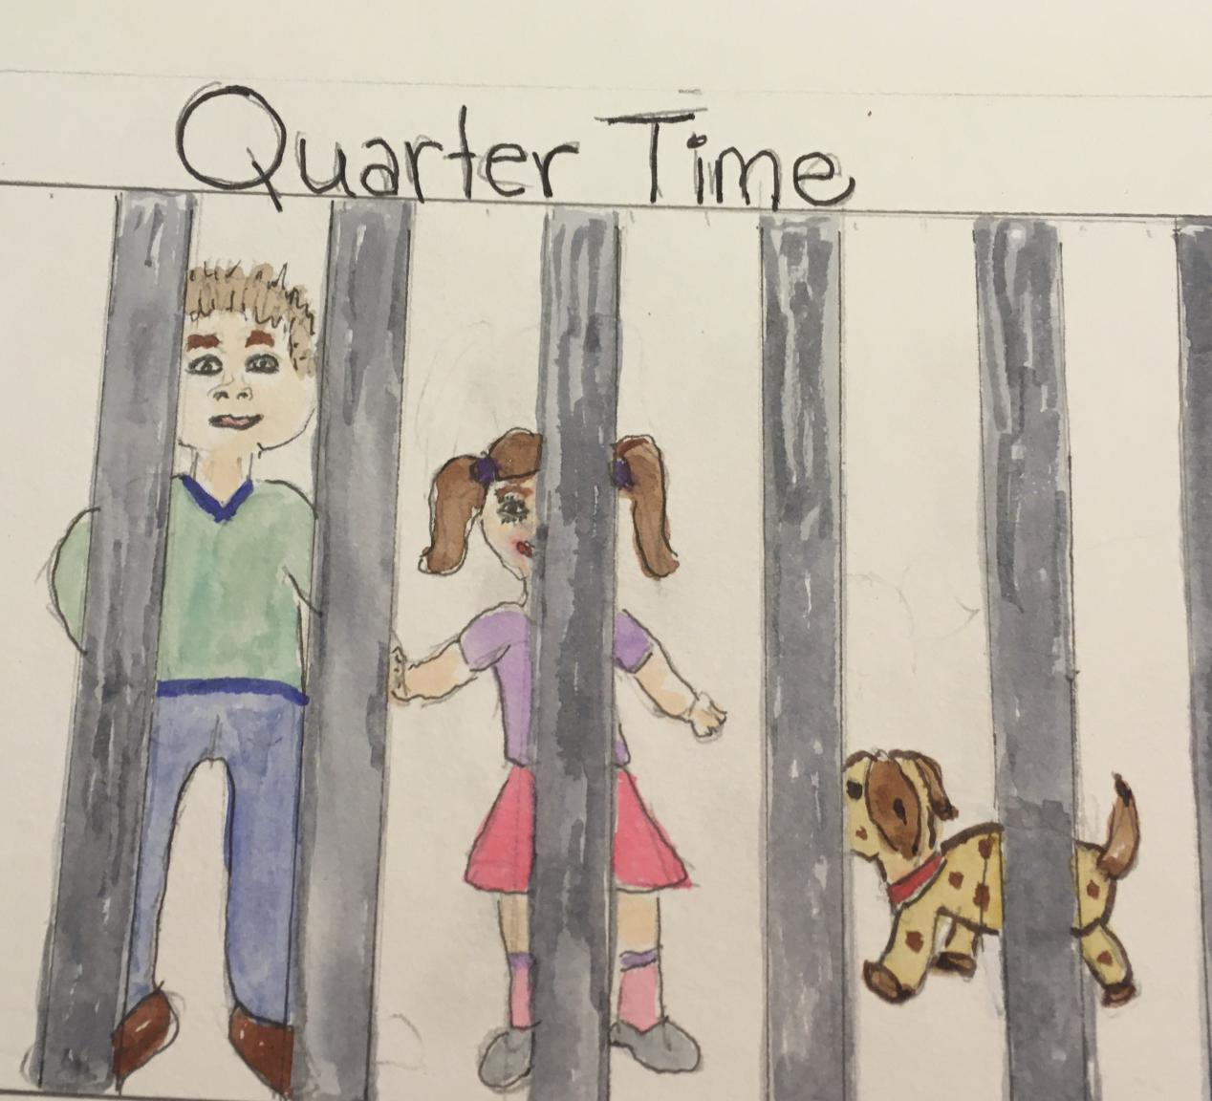

From that point on, things really started turning upside down. This flu seemed to scare all of our parents. I started to become worried about

catching it myself. After all, I had the flu last year when I had to miss a

whole week of school. How different could this be? If I did catch it, I sure

hoped it wouldn’t cause me to bite people, so I would be put in quartertime

like Kim’s dad was. Do you think they keep the *quartertimed* dogs and

people in the same place? That would be horrendous! Maybe I’ll ask Kim’s

dad, who’s back home now, the next time I see him; he’ll know for sure.

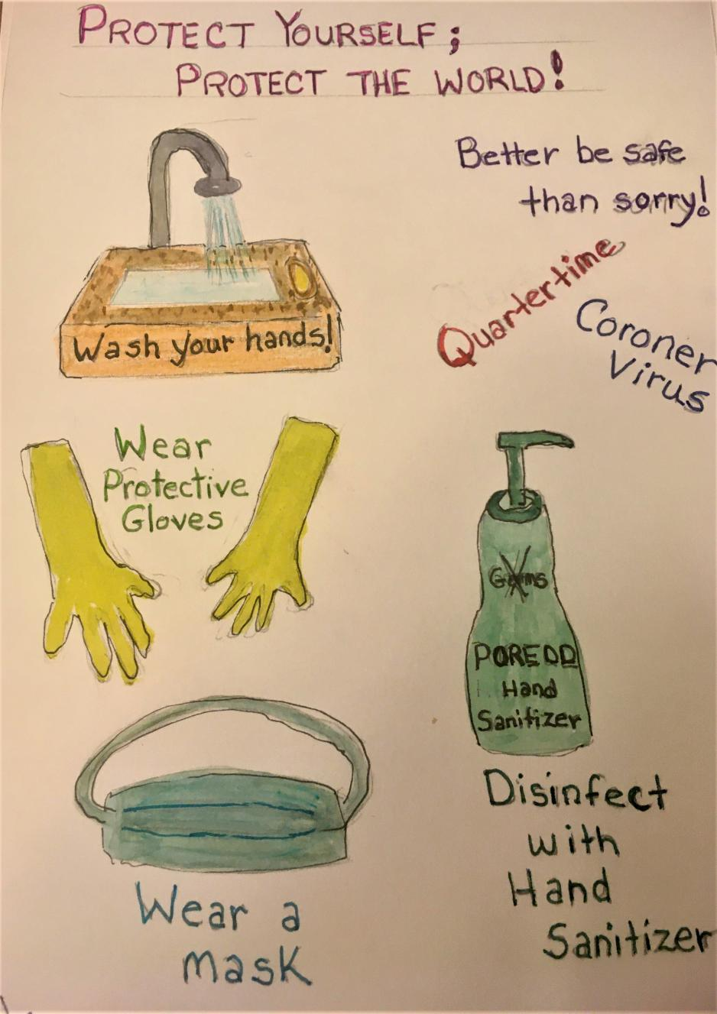

By the time Spring Break came, most of my school friends had their

vacation plans canceled too, so at least I had lots of friends in soccer camp with me. It was actually fun, but the coaches seemed obsessed with us

washing our hands every minute, and they even made us use hand sanitizer

before and after each game and before lunch. You’d think we were being

attacked by an army of deadly germs. To make things even worse, my

parents suddenly insisted on the same thing. Kacey and I had to wash our

hands all the time and use hand sanitizer every time we came into the

house from outside. However, by far the most bizarre habit they enforced

during this time was the wearing of half masks and rubber gloves whenever

we dared to leave our house. This was becoming so freaky I felt like I had

entered the Twilight Zone.

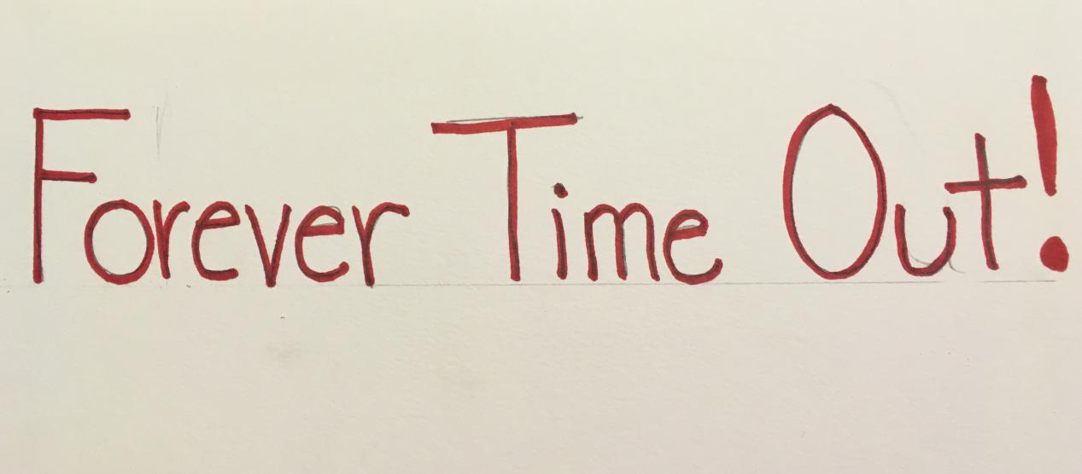

This Twilight Zone began to take over more and more of my life with

each day. Now, all the adults were constantly talking about the flu and how

it had spread to Italy, Thailand, Japan and was moving into Europe.

Although I had never been to any of those places and knew they were very

far away, I realized this was much more serious than I had previously

believed. One night near the end of our Spring Break, my mom and dad

called Kacey and me into the kitchen, “We need to talk to both of you

about the situation concerning a disease which began a while ago in China.”

It was strange they did not realize we had already heard bits and

pieces of this on our own, but I for one was eager to hear the whole story.

When we all went into the family room to talk, both Mom and Dad looked

very serious which set the tone immediately. “ We know you were both

disappointed we had to cancel our cruise, but it was for your own safety.

Now, your schools aren’t going to reopen next Monday as planned due to

the spread of a flu like disease which began in China called the *coroner*

*virus*.” In order to remain safe and healthy, we all have to remain at home

for at least two weeks to see if we can stop it from spreading more.”

I was so shocked, I couldn’t even say a word. At first, I was excited to

hear our vacation would be extended, but very quickly it sunk in that we

would be home bound for at least fourteen days with NO SOCCER, NO

BASKETBALL, NO BIKE RIDES OR WALKS WITH MY FRIENDS! In other

words, I would be in jail with my parents and big sister; this was worse than

the Twilight Zone. It was a FOREVER TIME OUT!

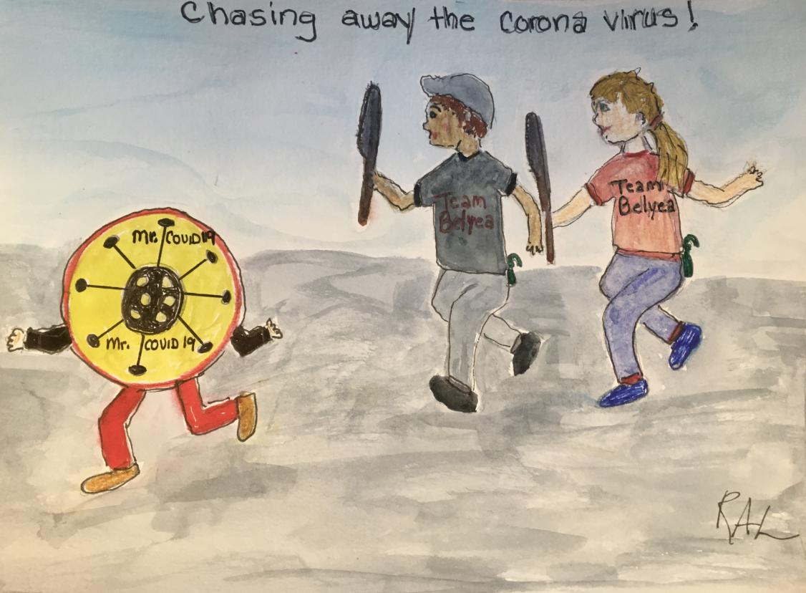

By this time, I had surmised the *coroner virus* was not at all like the

usual flu. I even looked up both words in Kacey’s dictionary and discovered

*coroner* meant someone who finds the cause of death, and *virus* meant an

infection which spreads rapidly from human to human and makes them sick.It didn’t take a genius to realize this *coroner virus* was deadly, spread

rapidly, and was an enemy we needed to defeat.

From that day forward, we all worked as a team to keep the enemy at

bay and protect ourselves and our neighbors from its evil germs.

Hand sanitizer became more precious to us than fortnight and tv, and paper

towels and toilet paper were being sold through the underground black

market at outrageous prices just like Super Bowl or World Series tickets.

Team Belyea, our family’s battle name, was in this fight 100% as were many

of our friends and the rest of our extended family.

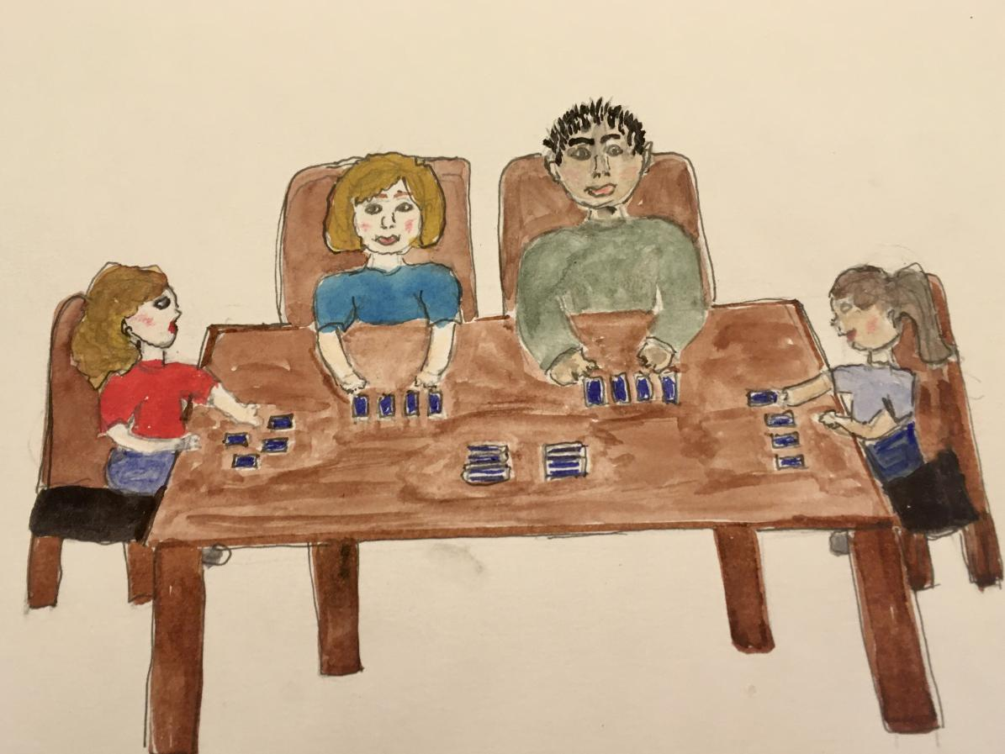

In a weird sort of way, this crisis brought us all closer together by

bring us together in a joint purpose. Suddenly, all our neighbors were

helping one another “at the recommended six foot distance” by sharing

groceries, recipes, survival plans, and moral support. Even Kacey and I

stopped bugging one another as we navigated online education and other

aspects of the “new” normal. Since Mom and Dad suddenly had to work

from home, we ate all our meals together which hadn’t ever happened in my

lifetime before this. Since we couldn’t attend our practices, and Mom and

Dad couldn’t go to meetings, we had lots of family time which was really

terrific. We didn’t lose sight of the serious crisis, but we were also

learning some really cool lessons we never would have learned if life had

stayed the same. I began to enjoy e-learning since it gave me much more

independence, let me move at my own pace, and left me more free time. I

really loved playing games as a family, and we even mastered several

electronic options which allowed us to include our grandma like the game

Psych and the app ZOOM.

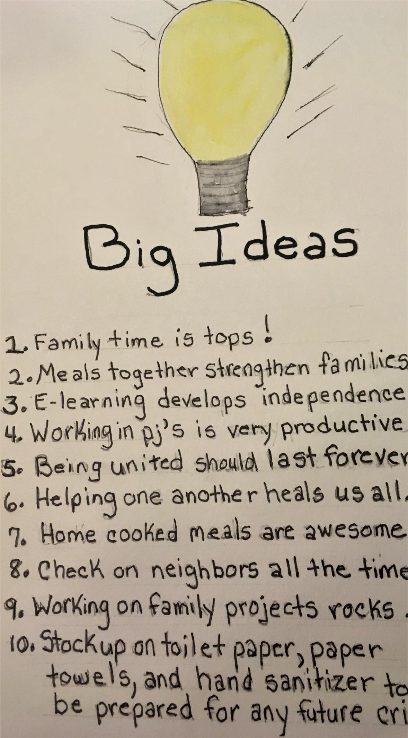

This “new” normal became more than okay, and we gradually began to

realize how unimportant many of our old “necessities” really were. I

discovered Mom was not really a blond as her brown roots became more

visible every day, but to tell the truth, I thought she was just as beautiful

with two colored hair as she had been all blond. We had a ball working out

together to some really fun workout videos we never would have

discovered before this change. Believe it or not, both Kacey and I even

started reading books and had fun reading them on face time with our

grandma who had taught literature and always wanted us to love reading as

much as she did. Reading together every day became our special time

together which I actually hope we can continue once things go back to

normal. In fact, the more I think about it, I hope many of the changes we experienced during this period stay permanent. Let me share with you my list of lessons

worth keeping.

**Lessons we should learn from the Coroner Virus**

1. Family time should be a # 1 activity for kids and parents.

2. Breakfast and/or dinner should be shared as a family as many

days of the week as possible .

3. Online learning should be encouraged since it develops independence

and allows kids to move at their own pace.

4. Adults and kids can work just as well in their pajamas as they do in

uncomfortable work and school clothes.

5. If we can work together during a serious crisis, we should be able to

work together during good times.

6. We should reach out and help one another all the time instead of

only during times of disasters.

7. Cooking meals is much better and cheaper than buying fast food,

carry out, or going out to eat at a restaurant.

8. Families and friends should check in with one another all the time

instead of only during a medical crisis.

9. Families should work together on projects to help make our world a

better place now and in the future.

10. We should always stock up on toilet paper, paper towels, and hand

sanitizer in order to be prepared in case of another crisis.